Report about best devices in PC, best operating system and suitable programming languages.
System Name:
- Best Devices
Dell :great for business and works 9-10 without battery.
Lenovo :Suitable for business
- Best Operating System
Windows11:support .Net frame work ,Visual studio,SQL Server
Linux:secure and ideal for hosting Database
MacOS :Cross platform Testing
- Suitable Programming Languages

C# :Backend /Desktop App
Python : Semplifies Coding
SQL: Quering and managing Data from database

Design of an integrated system (Class diagram)

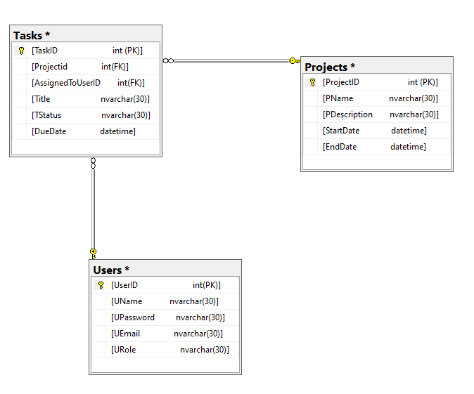

Testing
Test case ID | Test case description | Test Steps | Test Data | Expected Result | Actual Result | Pass/Fail
1 | Login for Manager | Enter valid username and password | Username=ENg  Password=eeee | Successful login and enter Manager page | Successful login and enter Manager page | Pass
2 | Login for Manager | Enter invalid username and password | Username=eee  Password=eeee | Failed login and not enter Manager page | Failed login and not enter Manager page | Pass
3 | Login for Manager | Enter blank username and password | Username=  Password= | Successful login and enter Manager page | Failed login and not enter Manager page | Fail
4 | Login for Developer | Enter blank username and password | Username=  Password= | Successful login and enter Developer page | Failed login and not enter Developer page | Fail
5 | Login for Developer | Enter valid username and password | Username=Basmalla  Password=bbbb | Successful login and enter Developer page | Successful login and enter Developer page | Pass
6 | Login for Developer | Enter invalid username and password | Username= khd  Password=wer | Failed login and not enter Developer page | Failed login and not enter Developer page | Pass

